Hydrolysis of Soybean Meal Protein by Pepsin and Its Effect as Antimicrobial and Anti-Inflammatory

Shaimaa Mohamed Badr, Ahmed Mohamed and Nadia Y. Attia*
Biochemistry Dept., Fac. Agric., Benha University, Egypt
Corresponding author: shaimaa.badr@fagr.bu.edu.eg

Abstract
Soybean meal (SM) is considered a by-product of soybean that is obtained after oil production. SM is a rich source of protein that contains about 45%. It is a good source of bioactive peptides because of its content of amino acids that includes all essential amino acids such as Leu, Phe, Lys and Met were (8.14%, 6.25%, 5.37% and 1.12%) respectively. Protein of SM was isolated by isoelectric point and precipitated at pH 4.5. Hydrolysis of soybean meal protein (SMP) was performed by pepsin enzyme. The molecular weight of SMP and its hydrolysates was determined by SDS-PAGE. Peptides that were obtained by enzymatic hydrolysis were fractionated and resulted in peptides 1 (<10kDa) and peptides 2 (>10kDa). Peptides 1 and 2 were tested as anti-inflammatory and antimicrobial agents. The anti-inflammatory effect of peptides was measured using RAW264.7 cells and the inhibition of nitric oxide (NO) at different concentrations. The best effect of peptides 1 and 2 was at concentration (400 µg mL ⁻¹) 24.9% and 29.7% respectively. The anti-microbial effect of peptides was determined by using four strains of bacteria: (Escherichia coli ATCC 8739, Pseudomonas aeruginosa ATCC 9027, Listeria monocytogenes ATCC 13932 and Bacillus cereus ATCC 9634). Peptides showed a good effect against E. coli at a concentration (1000 µg mL⁻¹) as the MIC of peptides 1 and 2 against it was (0.25 mg mL⁻¹ (and the inhibition zone was19 mm for the two peptides.

Keywords: Soybean meal, Protein hydrolysates, Peptides, Pepsin, Antimicrobial, Anti-inflammatory.

Introduction

Soybean (Glycine max) was cultivated in the Middle East since ancient times, because it was a good source of lipid and protein foods (Minh, 2015). Soybean had a lot of interest because it contains a large amount of protein, minerals, vitamins and fiber, so it was a good food for people who didn’t eat meat (Anna Laura Capriotti et al., 2015).
Much attention was directed towards soybean and its protein because they have lots of good features such as being inexpensive, very useful for nutrition and health of people (Lammi et al., 2019). The chemical structure of soybeans could be changed by genetic engineering or breeding programs to meet the needs of humans or industry (Xu et al., 2019). Soybeans are rich in iso-flavonoids, proteins, lecithin, minerals and vitamins, also Soybeans have a lot of bioactive molecules which make it useful in various applications such as health and food (Dulliusa et al., 2020).
The flour obtained from soybean was inexpensive residue, that could be extracted by alkaline and obtained by isoelectric point precipitation. Protein obtained from soy flour was 70% and its purity would be 91% (Lee et al., 2016) . Hydrolysis of protein could be done by enzymes, acids, microbial fermentation or temperature (Conti et al., 2019). The production of soybean meal was about (122 million tons year⁻¹), and its content of protein was approximately 45%, so it was used in abundance (Gorguc et al., 2020).
Soybean meal was obtained while extracting oil from soybean seeds, so that it was the chief residue of soybean (Mukherjee et al., 2016). Soybean meal's content protein was about 46%, making it was one of the best sources of protein extracted from plants. lately, soybean meal has gotten a lot of interest (Li et al., 2019; Álvarez-Viñas et al., 2020 and Rodionova et al., 2021 ). Utilization of different sources to produce protein hydrolysates such as oil seeds, peas, soybeans, lentils and beans depended on two reasons, the first was raising their benefit and promoting their utilization; the second was employing peptides in functional foods and treating adverse diseases (Carlos Sgarbieri, 2017). Soybeans have also lots of peptides that had a perfect effect on health such as anticancer, antidiabetic, antioxidant, anti-inflammatory, antihypertensive, anti-obesity, immunomodulatory, hypolipidemic and neuromodulator characteristics (Dukariya et al., 2020).
Bioactive peptides (BP) were considered short chains of amino acids that enhance the biological functions of human̕ s body, so BP were very useful for health (Sánchez and Vázquez, 2017). utilization of BP had beneficial effects on the human body as there were anti-inflammatory, antihypertensive, immunomodulatory, antioxidant, antimicrobial and anticancer peptides, because of that BPs were used in the protection of foods from spoilage factors (Toal´a et al., 2022). BPs could be obtained by hydrolysis of protein by proteolytic enzymes, fermentation by microbes or gastrointestinal proteases (Agyei et al., 2016; Chakrabarti et al., 2018 and Tüysüz et al., 2019). Hydrolysis of protein by enzymes was used more than fermentation because of mild conditions, specificity, shortage of toxic chemicals and solvents in the end product (Lemes et al., 2020 and Ulug et al., 2021). While, the biological effects of (BPS) depended on the sequence of amino acids, charge and molecular weight of peptides (Acquah et al., 2018).
Isolation of protein and its hydrolysates could be done by using ultrafiltration (UF) membranes, electrophoresis, chromatography and resin adsorption, but ultrafiltration was applied in many fields such as the food industry ( Ratnaningsih et al., 2021 and Liang et al., 2023). Soy peptides that could cure cancer also have the ability to treat inflammation and prevent oxidative stress in the body (Chatterjee et al., 2018). The aim of this study is to produce BPs from plants by-product soybean meal and study their biological effects as anti-inflammatory and anti-microbial.

Materials and methods

1. Materials:
All chemicals used in experiments were provided by Sigma Chemical Company of high quality and purity. Argentinian Soybean meal (Dorada) was obtained from Danon Farm, Egypt. All bacteria strains such as Escherichia coli ATCC 8739, Pseudomonas aeruginosa ATCC 9027, Listeria monocytogenes ATCC 13932, Bacillus cereus ATCC 9634 and also Mouse macrophage cell line was obtained from Nawah Scientific Inc., (Mokatam, Cairo, Egypt).

2. Analytical methods:
Crude protein of soybean meal was determined by Kjeldahl method and other components such as total lipid, ash and moisture were determined according to the method of the Association of Official Analytical Chemists A.O.A.C. (2019).

2.1. Calculation of total carbohydrates:
The total carbohydrates of the sample under investigation were calculated as the difference between 100 and the sum of the percentage amounts of total protein, lipid, moisture, and ash by subtraction according to Tassi et al. (2019).
2.2. Isolation of protein from soybean meal:
The sample of soybean meal was grounded by blender and sieved by a mesh screen for protein extraction and stored at 4 ̊ C. Each 10 grams of the sample were mixed with 300 milliliters of sodium hydroxide 1M and stirred for 4 hours then filtered and the pH was adjusted to 4.5 by using HCl 1N for the precipitation of protein. After precipitation protein obtained by centrifugation at 10.000 rpm for 15 min, then the protein was lyophilized, and stored at 4 ̊ C until used (Chen et al., 2019).
2.3. Determination of amino acids by using GLC:
The technique of fractionation of amino acids was applied by gas liquid chromatography (GLC) recommended by Mabbot (1990) and was done in College of Veterinary Medicine, Benha University, Egypt.
2.4. Hydrolysis of soybean meal protein by pepsin:
Soy protein isolate (SPI) was dissolved in deionized water in a ratio of 1:8 (w ̸v). Hydrolysis of SPI with pepsin was carried out at 37 ̊ C and pH 2 using 2M HCl, and enzyme substrate ratio of 0.5% ̸ 100 g substrate. The SPI was pre-incubated for 15 min at 37 ̊ C prior to hydrolysis process. The hydrolysis time was set at 4h. The enzyme was inactivated using heat temperature at 95 ̊ C for 15 min in a thermostat-controlled water bath. Afterwards, the sample was cooled on ice to room temperature and centrifuged at 4 ̊ C, 10,000 rpm for 20 min to separate the supernatant from the pellet. Finally, the supernatant (soy protein hydrolysate) was lyophilized and stored at -20 ̊ C according to Ashaolu et al. (2017).
2.5. Determination of protein subunits molecular weight by using Sodium dodecyl sulfate- polyacrylamide gel electrophoresis (SDS-PAGE):
Total cellular proteins of both vegetative and sporulated cells of the three isolates were analyzed by SDS-PAGE. Proteins were separated based on molecular weight by Sodium Dodecyl Sulfate Polyacrylamide Gel Electrophoresis (SDS-PAGE) according to Laemmli, (1970). (SDS-PAGE) was done in Agriculture Genetic Engineering Research Institute, Egypt.
2.6. Ultrafiltration of soy protein hydrolysates:
The first separation of the peptide fraction based on the soybean hydrolysates molecular weight was determined using the MWCO (Molecular Weight Cut Off) ultrafiltration membrane. The ultrafiltration membrane with a cut off 10 kDa ultrafiltration membrane size 2 mL was applied. Two mL of soybean hydrolysate was inserted into the ultrafiltration membrane, then centrifuged at 8000 rpm at 4 ºC for 30 min. This process was repeated until there was no more dripping or dropping from the membrane. The solution that descends or escapes from the membrane was then called permeate, and the non-escape solution was named retentate. The retentate, next, was added with 1.5 mL distilled water per ultrafiltration membrane according to Giarni et al. (2020).

2.7. Determination of antimicrobial activity of soy protein hydrolysates:
A disc of each Escherichia coli ATCC 8739, Pseudomonas aeruginosa ATCC 9027, Listeria monocytogenes ATCC 13932, Bacillus cereus ATCC 9634 were inoculated into 100 mL of tryptic soy broth medium and incubated at 37.0 ˚C ± 1.0 for 24 h. for preparation of fresh (18-24 h.) culture agar plate, a loopful from broth was streaked onto Tryptic Soy Agar medium. Then incubated at same previous temperature. Peptides were tested at concentration (1000 µg mL⁻¹) for each strain. A negative control (NC) well containing only the broth without sample nor bacteria was added to each sample plate. Upon incubation, MIC minimum inhibitory concentration was determined visually depending on well turbidity. The Agar Well Diffusion Method (paper disk method) was used for detection of the bacteriocin-like substances BLS-producing activity. All dishes were incubated at 37.0 °C ± 1.0 °C for 24 ± 2 h. After Incubation period, the inhibition zone was measured and calculated: X = a-b, where “a” is the inhibition zone diameter and “b” is the well’s diameter (11 mm) (Balouiri et al., 2016).

2.8. Anti-inflammatory effect of bioactive peptides:
The RAW 264.7 Cells were maintained in Dulbecco’s Modified Eagle Medium
DMEM media supplemented with 100 mg mL⁻¹ of streptomycin, 100 units mL⁻¹ of penicillin and 10% of heat-inactivated fetal bovine serum in humidified, 5% (v/v) CO₂ atmosphere at 37 °C.

2.9. In-Vitro Anti-inflammatory assay:
RAW264.7 Cells were seeded into a 96-well plate and incubated for twenty-four hours. The next day, inflammation was induced with 1μg mL⁻¹ of lipopolysaccharide (LPS-group), and untreated cells will be replenished with fresh media (Control group). Compounds will be treated with LPS in two/five concentrations (LPS+ Drug). Dexamethasone (1µM) was used as an anti-inflammatory positive control. To measure nitric oxide (NO) secretion, equal volumes of the cell supernatant and Griess reagent were mixed for 10 min in the dark at room temperature. The absorbance at 540 nm representing the nitrite concentration was measured using an ELISA plate reader (Tang et al., 2019; Kim et al., 2021 and Ahmed et al., 2022).
2.10. Statistical analysis:
Statistical analysis was performed using SPSS 22.0 for Windows. Experimental results were expressed as mean ± SE. Statistical significance was tested with one-way ANOVA followed by post hoc test and p-values < 0.05 were applied according to Steel, (1997).
3. Results and Discussion:
3.1. Chemical composition of soybean meal (g 100g⁻¹ on dry matter):
The chemical composition of soybean meal (moisture, protein, ash, lipids and carbohydrate) was (9.5%, 44.6%, 6.6%, 2.1% and 37.2%) respectively. It could be concluded that soybean meal is an excellent source of protein. These results were almost similar to those obtained by Tang et al. (2020); Ali El-Tanany et al. (2021) and Janocha et al. (2022).
(Yu et al., 2018) reported that the chemical composition of SBM (dry matter basis) was 45.82% crude protein, 6.41% crude ash, 7.44% moisture, 3.56% ether extract.

3.2. Soybean protein amino acids by GLC:
Amino acids composition of soybean meal protein is shown in Table (1).
The results demonstrated txhat protein of soybean meal contained a large amount of nonessential amino acids. The nonessential amino acids were (59.83%) of total amino acids. The major amino acids were Glu (12.38%) followed by Gly (9.24%) and Pro (8.60%), but essential amino acids represented (35.69%). Leucine is considered the big component of essential amino acids (8.14%) followed by Phe (6.25%), Lys (5.37%), but Met (1.12%), Trp (1.67%) and His (2.28%) showed the lowest percentage of amino acids and these results agreed with those reported by Zhang et al. (2019) and Ibáñez et al. (2020).
(Ibáñez et al., 2020) found that the amino acids of soybean protein (g/100g) were 2.73 His, 7.28 Arg, 7.66 Leu, 1.44 Cys, 5.09 Phe, 1.40 Trp, 1.36 Met, 4.54 Ile, 4.78 Val, 6.16 Lys and 3,85 Thr.

Table 1. Amino acids of soybean meal protein:
Amino Acids | Protein isolate
*Essential Amino Acids  His | 2.28
Ile | 3.65
Arg | 6.92
Lys | 5.37
Phe | 6.25
Met | 1.12
Thr | 4.19
Trp | 1.67
Val | 3.02
Total | 34.47
*Non-Essential Amino Acids  Ala | 4.15
Leu | 8.14
Asp | 7.33
Cys | 0.81
Gly | 9.24
Glu | 12.38
Pro | 8.60
Ser | 6.86
Tyr | 3.54
Total | 61.05

3.3. SDS-PAGE of soybean protein isolate (SPI) and its hydrolysates:
SDS-PAGE showed the molecular weight of SPI and its hydrolysates that ranged from (20-120 KDa) and that are shown in Fig. (1). The lanes showed that hydrolysis of SMP by pepsin enzyme resulted in small molecules of protein reached to ≤ 20 kDa which called bioactive peptides and that indicated by intensity of bands color after protein hydrolysis in lane (2) when compared those with bands of lane (1) which represent SPI before enzyme hydrolysis and the results are in agreement with Nath et al. (2020).

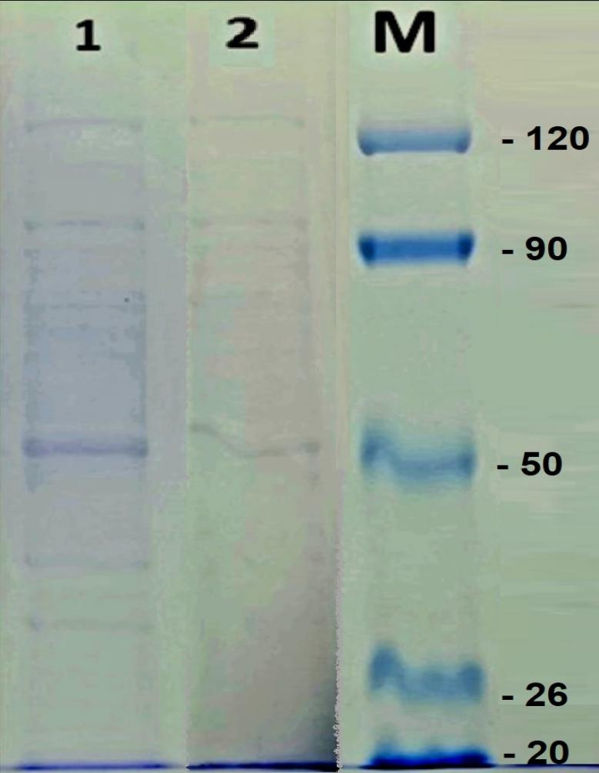

Figure (1): SDS-PAGE of soybean meal protein (1) and its hydrolysates (2), M referred to marker protein.

3.4. Anti-inflammatory effect of bioactive peptides:
Nitric oxide (NO) was a free radical that could interacted with superoxide anions, producing an oxidant that reacted with and destroyed cell membranes and molecules, and that causing death of the cell. However, macrophages generated compounds against pathogens as an intermediate in their cytotoxic action, favoring their phagocytic activity (Franca-Oliveira et al., 2023) Peptides that obtained after ultrafiltration were divided into peptides 1 (<10KDa) and peptides 2 (>10Kda) and they were tested against inflammatory by using RAW 264.7 cells with different concentrations of peptides (25, 50,100,200 and 400 µg mL⁻¹) for 24h and that showed in Table (2). The results showed that peptides 2 were better than peptides 1 in (25 and 50 µg mL⁻¹) concentrations, but in concentration of (100 µg mL⁻¹ ) peptides 1 were better than peptides 2 (18.9% and 17.9%) respectively, after that peptides 2 were higher than peptides 1 in (200 and 400 µg mL⁻¹ ) concentrations and the highest value of inhibition of NO was 29.7% of peptides2 and 24.9% of peptides 1 in (400 µg mL⁻¹ ) con. And that showed in Fig. (2). These results indicated that SMP hydrolysates could be used as anti-inflammatory agent and these results like that reported by Kim et al. (2017) who found that the inhibition of NO by peptides that (<10 kDa) was 25.01% and that was at concentration 400 µg mL⁻¹.

Table 2. Anti-inflammatory effect of bioactive peptides:
Concentration  (µg mL⁻¹) | Peptides 1  (< 10 KDa)  Mean ± Std.  (Inhibition of NO%) | Peptides 2  (> 10 KDa)  Mean ± Std.  (Inhibition of NO%)
25 | 5.857 ± 1.37 | 12.552 ± 1.80
50 | 10.460 ± 0.90 | 13.389 ± 0.90
100 | 18.967 ± 1.54 | 17.991 ± 0.90
200 | 22.315 ± 0.79 | 24.546 ± 2.95
400 | 24.965 ± 2.27 | 29.707 ± 1.78

Figure 2. The effect of peptides 1 and 2 as anti-inflammatory agents against NO by using RAW 264.7 cells

3.5. Antimicrobial effect of soybean protein bioactive peptides:
Peptides obtained after ultrafiltration were examined against pathogenic bacteria such as (E. Coli ATCC 8739, P. aeruginosa ATCC 6538 considered gram negative bacteria, L. monocytogenes ATCC 13932 and B. cereus ATCC 9634 (gram positive bacteria) and that presented in Table (3). The peptides were used at concentration (1 mg mL⁻¹) with 4 strains of bacteria, the minimum inhibitory concentrations (MIC) of peptides 1 and peptides 2 were (0.25, 0.5, 0.5 and 0.5 mg mL⁻¹). Results demonstrated that the effect of peptides 1 and 2 was almost similar to each other and that was shown in Fig. (3). E. coli was the lowest MIC and Inhibition Assay by Well diffusion of peptides 1 and 2 was (19 mm) for E. coli, but peptides exhibited no inhibition against P. aeruginosa, L. monocytogenes and B. cereus, as shown in Fig. (4). These results showed that peptides obtained from SMP had a good effect as antimicrobial agent. Antimicrobial peptides influenced specific against gram-negative bacteria, because of their content of lipopolysaccharides that had a big amount of negative charge and made the conjugation to peptides that had positive charge easier and that destroyed the outer membrane of these bacteria. Peptidoglycans of gram-positive bacteria had lipoteichoic and teichoic acids, so they were also exposed to antimicrobial peptides. Vasconcellos et al., (2014) studied the effect of two peptides on some bacterial strains such as E. coli and P. aeruginosa at (1000 µg mL⁻¹) concentration and found MIC against E. coli was (3.12 µg mL⁻¹) for two peptides and (3.12-12.5 µg mL⁻¹) for P. aeruginosa and the inhibition zone was (32-24 mm) and (30.5-22 mm) respectively, these results were better than that reported in Table (3).

Table 3. The effectiveness of bioactive peptides on four strains of bacteria gram positive and negative microorganisms:
Microorganism | Minimum Inhibitory Concentration by Macro dilution Broth (mg mL⁻¹) |  | Inhibition Assay by Well diffusion method (mm)
Microorganism | Peptides 1 | Peptides 2 | Peptides 1 | Peptides 2
E. Coli ATCC 8739 | 0.25 | 0.25 | 19 | 19
P. aeruginosa ATCC 6538 | 0.5 | 1.0 | No inhibition | No inhibition
L. monocytogenes ATCC 13932 | 0.5 | 0.5 | No inhibition | No inhibition
B. cereus ATCC 9634 | 0.5 | 0.5 | No inhibition | No inhibition
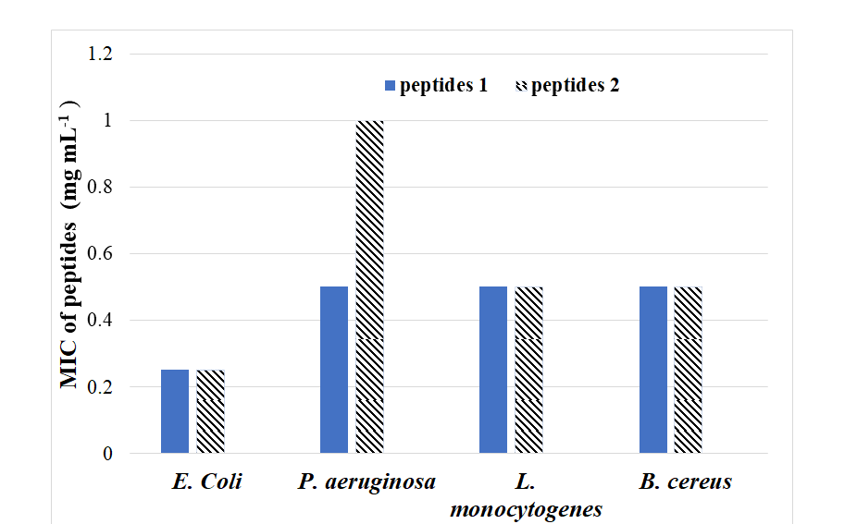

Figure (3): The MIC of peptides for four strains of bacteria E. coli, P. aeruginosa, L. monocytogenes and B. cereus.
Peptides 1 | Peptides 2
E. coli ATCC 8739
P. aeruginosa ATCC 9027
B. cereus ATCC 9634
L. monocytogenes ATCC 13932

Figure (4): The effectiveness of bioactive peptides on four strains of bacteria E. coli, P. aeruginosa, L. monocytogenes and B. cereus.

Conclusion
Bioactive peptides that are produced by enzymatic hydrolysis from soybean meal have a good biological effect on the health of humans. They can act as antimicrobial and anti-inflammatory factors, because of their beneficial effects they could be used as natural source for the treatment of fetal diseases instead of drugs that had side effects on health.

References

Acquah, C., Stefano, E. D. and Udenigwe, C. C. (2018) Role of hydrophobicity in food peptide functionality and bioactivity: Journal of Food Bioactives, v. 4, p. 88–98.
Agyei, D., Ongkudon, C. M., Wei, C. Y., Chan, A. S. and Danquah, M. K. (2016) Bioprocess challenges to the isolation and purification of bioactive peptides: Food and Bioproducts Processing, v. 98, p. 244-256.
Ahmed, A. H. H.; Mohamed, M. F. A.; Allam, R. M.; Nafady, A.; Mohamed, S. K.; Gouda, A. E. and Beshr, E. A. M. (2022). Design, synthesis, and molecular docking of novel pyrazole-chalcone analogs of lonazolac as 5-LOX, iNOS and tubulin polymerization inhibitors with potential anticancer and anti-inflammatory activities. Bioorganic Chemistry, v. 129, no. 106171.
Ali El-Tanany, R. R., Ali Chiab, A. B., Abd El-Gawad El-Banna, H. M., Ali Mostafa, A. M. and Mahmoud, A. E. M. (2021). Impact of Replacing Soybean Meal with Sunflower Meal, Sesame Meal, and Black Seed Meal in diets of Barki Lambs: World's Veterinary Journal, v. 11, no. 4, p. 670-677.
Álvarez-Viñas, M., Rodríguez-Seoane, P., Flórez-Fernández, N., Torres, M. D., Díaz-Reinoso, B., Moure, A. and Domínguez, H. (2020). Subcritical Water for the Extraction and Hydrolysis of Protein and Other Fractions in Biorefineries from Agro-food Wastes and Algae: a Review: Food and Bioprocess Technology, v. 14, no. 3, p. 373-387.
Anna Laura Capriotti, G. C., Cavaliere, C., Samperi, R., Ventura, S., Chiozzi, R. Z. and Aldo Lagana`, (2015). Identification of potential bioactive peptides generated by simulated gastrointestinal digestion of soybean seeds and soy milk proteins: Journal of Food Composition and Analysis, v. 44, p. 205–213.
A.O.A.C. (2019). Official methods of analysis of analytical ״18 ^{th}״ ED. Association of Official Analytical Chemists, Gaithersburg, Maryland, U.S.A.
Ashaolu, T. J.; Yanyiam, N. and Yupanqui, C. T. (2017). Immunomodulatory effects of pepsin-educed soy protein hydrolysate in rats and murine cells. Functional Foods in Health and Disease; v. 7, no. 11, p. 889-900. https://doi.org/10.31989/ffhd.v7i11.400.
Balouiri, M., Sadiki, M. and Ibnsouda, S, K. (2016). Methods for in vitro evaluating antimicrobial activity: A review: Journal of Pharmaceutical Analysis, v. 6, p. 71-79.
Carlos Sgarbieri, V., (2017), Food Proteins and Bioactive Peptides, Functional Diets: Food Science & Nutrition, v. 3, no. 2, p. 1-14.
Chakrabarti, S., Guha, S. and Majumder, K. (2018). Food-Derived Bioactive Peptides in Human Health: Challenges and Opportunities: Nutrients, v. 10, no. 11.
Chatterjee, C., Gleddie, S. and Xiao, C. W. (2018). Soybean Bioactive Peptides and Their Functional Properties: Nutrients, v. 10, no. 9.
Chen, Z., Li, W., Santhanam, R. K., Cong Wang, C., Gao, X., Chen, Y., Wang, C., Xu, L. and Chen, H. (2019). Bioactive peptide with antioxidant and anticancer activities from black soybean [Glycine max (L.) Merr.] byproduct: isolation, identification and molecular docking study: European Food Research and Technology, v. 245, p. 677–689.
Conti, J. P., Vinderola, G. and Esteban, E. N. (2019). Characterization of a soy protein hydrolyzate for the development of a functional ingredient: Food Sci Technol, v. 56, no.2
Dukariya, G., Shah, S., Singh, G. and Kumar, A. (2020). Soybean and Its Products: Nutritional and Health Benefits: Nutritional Science and Healthy Diet, v. 1, no. 2, p. 22-29.
Dulliusa, A., Fassinaa, P., Giroldia, M., Goettertc, M. I., de Souza, C. and Volken, F. (2020). A biotechnological approach for the production of branched chain amino acid containing bioactive peptides to improve human health: A review: Food Research International, v. 131 p. 109002.
Franca-Oliveira, G., Martinez-Rodriguez, A. J., Morato, E., and Hernández-Ledesma, B., 2023, Contribution of Proteins and Peptides to the Impact of a Soy Protein Isolate on Oxidative Stress and Inflammation-Associated Biomarkers in an Innate Immune Cell Model: Plants, v. 12, no. 2011. https://doi.org/10.3390/ plants12102011.
Giarni, R.; Saepudin, E.; Susanti, I. and Laily, N. (2020). Characterization of iron binding peptides from soybean hydrolysates produced by thermal and enzymatic process: AIP. Conference Proceedings v. 2242, p. 040056-1–040056-7.p. 040056-1 – 040056-7
Gorguc, A., Gencdag, E. and Yilmaz, F. M. (2020). Bioactive peptides derived from plant origin by-products: Biological activities and techno-functional utilizations in food developments - A review: Food Res Int, v. 136, no . 109504, p. 1-17.
Ibáñez, M. A., de Blas, C., Cámara, L. and Mateos, G. G. (2020). Chemical composition, protein quality and nutritive value of commercial soybean meals produced from beans from different countries: A meta-analytical study: Animal Feed Science and Technology, v. 267, no. 114531, p. 1-15.
Janocha, A., Milczarek, A., Pietrusiak, D., Laski, K. and Saleh, M. (2022). Efficiency of Soybean Products in Broiler Chicken Nutrition: Animals (Basel), v. 12, no. 3, p. 1-16.
Kim, C.; Le, D. and Lee, M. (2021). Diterpenoids Isolated from Podocarpus Macrophyllus Inhibited the Inflammatory Mediators in LPS-Induced HT-29 and RAW 264.7 Cells. Molecules, v. 26(14), no. 4326. https://doi.org/10.3390/molecules26144326
Kim, M. Y., Jang, G. Y., Oh, N. S., Baek, S.Y., Lee, S.H., Kim, K. M., Kim, T. M., Lee, J. and Jeong, H. S. (2017). Characteristics and in vitro anti-inflammatory activities of protein extracts from pre-germinated black soybean [Glycine max (L.)] treated with high hydrostatic pressure Innovative: Food Science and Emerging Technologies, v. 43, p. 84-91.
Laemmli, U. K. (1970). Cleavage of structural proteins during the assembly of the head of bacteriophage T_{4.} Nature, v. 227, p. 680-685.
Lammi, C., Aiello, G., Boschin, G. and Arnoldi, A. (2019). Multifunctional peptides for the prevention of cardiovascular disease: A new concept in the area of bioactive food-derived peptides: Journal of Functional Foods, v. 55, p. 135-145..
Lee, H., Yildiz, G., dos Santos, L. C., Jiang, S., Andrade, J. E., Engeseth, N. J. and Feng, H. (2016). Soy protein nano-aggregates with improved functional properties prepared by sequential pH treatment and ultrasonication: Food Hydrocolloids, v. 55, p. 200-209..
Lemes, A., C, de Paula, L., C, Filho, J., G,O, do Prado, D., M,F, Medronha, G., A. and Egea, M., B. (2020). Bioactive Peptides with Antihypertensive Property Obtained from Agroindustrial Byproducts – Mini Review: Austin Journal of Nutrition & Metabolism, v. 7, no. 3, p. 1082.
Liang, T., Lu, H., Ma, J., Sun, L. and Wang, J. (2023). Progress on membrane technology for separating bioactive peptides.: Journal of Food Engineering, v. 340, no. 111321.
Li, L., Qing, Y., Wang, J., Wang, Y., Liu, J. and Mou, H. (2019). Production of a water-soluble protein powder from anchovy and soybean meal by endogenous enzymatic hydrolysis and solid-state fermentation: Journal of Food Processing and Preservation, v. 43, no. 1, p. e13854.
Mabbot. A. G. (1990). Qualitative amino acid analysis of small peptide by GC. J. Chemical Education, v. 67, no. (5), p. 441-445.
Minh, N. P. (2015). Alcalase and Protamex Hydrolysis of Bioactive Peptides from Soybean: Bulletin of Environment, Pharmacology and Life Sciences, v. 4, n. 7, p. 132-143.
Mukherjee, R., Chakraborty, R. and Dutta, A. (2016). Role of Fermentation in Improving Nutritional Quality of Soybean Meal - A Review: Asian-Australas J Anim Sci, v. 29, no. 11, p. 1523-1529.
Nath, A., Kailo, G.G., Mednyánszky, Z., Kiskó, G., Barbara Csehi, B., Pásztorné-Huszár, K., Renáta Gerencsér-Berta, R., Galambos, I., Pozsgai, E., Bánvölgyi, S. and Vatai, G. (2020). Antioxidant and Antibacterial Peptides from Soybean Milk through Enzymatic- and Membrane-Based Technologies: Bioengineering, v.7, no. 5, p. 1-18.
Ratnaningsih, E.,Reynard, R., Khoiruddin, K., Wenten, I. G. and Boopathy, R. (2021). Recent Advancements of UF-Based Separation for Selective Enrichment of Proteins and Bioactive Peptides—A Review: Applied Sciences, v. 11, no. 3.
Rodionova, O. Y., Fernández Pierna, J. A., Baeten, V. and Pomerantsev, A. L., (2021), Chemometric non-targeted analysis for detection of soybean meal adulteration by near infrared spectroscopy: Food Control, v. 119., no. 107459.
Sánchez, A. and Vázquez, A. (2017). Bioactive peptides: A review: Food Quality and Safety, v. 1, no. 1, p. 29-46.
Steel, R. G. (1997). Principle and procedures of statistics a biometrical approach, 3rd ed. McGraw-Hill, New York, NY, USA. P. 139-203.
Tang, J.; Diao, P. and Shu, X. (2019). Quercetin and Quercitrin Attenuates the Inflammatory Response and Oxidative Stress in LPS-Induced RAW264.7 Cells: In Vitro Assessment and a Theoretical Model. Biomed Res Int, p. 1–8. https://doi.org/10.1155/2019/7039802
Tang, K., Zhang, M., Liu, D., Li, Y. and Zhang, P. (2020). Changes in molecular structure of protein and carbohydrate in soybean products with different processing methods and their effects on nutrient degradation characteristics of the products: Czech Journal of Animal Science, v. 65, no. 7, p. 233-246.
Tassi, A. L. W., Bento, J. A.C., Caliari, M., da Silva, V. S.N., Pacheco, M. T. B. and Junior, M. S. S. (2019). Physical and chemical characteristics of soybean preserve as a function of maceration time and acetic acid: Food Science and Technology, v. 39, no. (3), p. 552-558.
Toal´a, J. E. A., Guerrero, D. Q., M., L. A. and Zambrano Zaragoza, M. L. (2022). Encapsulation of bioactive peptides: a strategy to improve the stability, protect the nutraceutical bioactivity and support their food applications: the Royal Society of Chemistry, v. 12, p. 6449–6458.
Tüysüz, B., Dertlį, E., Çakir, Ö. and Şahįn, E. (2019). Bioactive Peptides: Formation and Impact Mechanisms: 3rd International Conference on Advanced Engineering Technologies, p. 736-743
Ulug, S. K., Jahandideh, F. and Wu, J. (2021). Novel technologies for the production of bioactive peptides: Trends in Food Science & Technology, v. 108, p. 27-39.
Vasconcellos, F.C.S., Woiciechowski, A.L., Soccol, V. T., Mantovani, D. and Soccol, C. R. (2014). Antimicrobial and antioxidant properties of -conglycinin and glycinin from soy protein isolate: Int. J. Curr. Microbial. App. Sci, v. 3, no. (8), p. 144-157.
Xu, Q., Hong, H., Wu, J. and Yan, X. (2019). Bioavailability of bioactive peptides derived from food proteins across the intestinal epithelial membrane: A review: Trends in Food Science & Technology, v. 86, p. 399-411.
Yu, M., He, S., Tang, M., Zhang, Z., Zhu, Y., and Sun, H. (2018). Antioxidant activity and sensory characteristics of Maillard reaction products derived from different peptide fractions of soybean meal hydrolysate: Food Chem, v. 243, p. 249-257.
Zhang, Y., Chen, S., Zong, X., Wang, C., Shi, C., Wang, F., Wang, Y. and Lu, Z. (2019). Peptides derived from fermented soybean meal suppresses intestinal inflammation and enhances epithelial barrier function in piglets: Food and Agricultural Immunology, v. 31, no. 1, p. 120-135.

التحلل المائى لبروتين كسب فول الصويا بواسطة الببسين وتاثيره كمضاد للميكروبات ومضاد للالتهابات

شيماء محمد بدر ، أحمد محمد ، نادية يحيي أحمد عطية
قسم الكيمياء الحيوية الزاعية، كلية الزراعة، جامعة بنها ، مصر

كسب فول الصويا يتم الحصول عليه من فول الصويا بعد استخلاص الزيت منه. وكسب الصويا هو مصدر غني بالبروتين حيث يحتوي على حوالي 45% بروتين بالاضافة الى انه مصدر جيد للببتيدات النشطة حيويا وذلك لاحتواه على جميع الأحماض الأمينية الأساسية مثل Leu وPhe وLys‏ وMet بنسبة (8.14%، 6.25%، 5.37%، 1.12%) على التوالي. تم استخلاص وتحضير بروتين فول الصويا المعزول بواسطة نقطة التعادل الكهربي وترسيبه عند درجة الحموضة 4.5، ومن ثم إجراء التحلل المائي له ‏ بواسطة إنزيم الببسين وتم تحديد الوزن الجزيئي لـلبروتين والببتيدات بواسطة SDS-PAGE تم تجزئة الببتيدات التي تم الحصول عليها إلى الببتيدات 1 (<10 كيلو دالتون) والببتيدات 2 (> 10 كيلو دالتون) واختبار الببتيدات 1 و 2 كعوامل مضادة للالتهابات ومضادة للميكروبات. تم قياس التأثير المضاد للالتهابات للببتيدات باستخدام خلايا RAW264.7 وتثبيط NO باستخدام تركيزات مختلفة من الببتيدات. حيث وجد أن أفضل تأثير للببتيدات 1 و 2 كان عند التركيز (400 ميكروجرام /مل) بنسبة 24.9% و 29.7% على التوالي. تم تحديد التأثير المضاد للميكروبات للببتيدات باستخدام 4 سلالات من البكتيريا وهى Escherichia coli ATCC 873 ، aeruginosa ATCC 9027 Pseudomonas‏ ‏ ، Listeria monocytogenes ATCC 13932 و Bacillus cereus ATCC 9634 أظهرت الببتيدات تأثيراً جيداً ضدE. Coli وذلك عند تركيز (1000 ميكروجرام /مل) حيث كان أقل تركيز مثبط لها بواسطة الببتيدات 1 و 2 هو (0.25 ملجم /مل) وكانت منطقة التثبيط لها 19 ملم .

الكلمات الدالة : كسب فول الصويا، الببتيدات، الببسين، مضاد للميكروبات، مضاد للالتهاب.

